**Project Design**

**AI-enhanced Application Security Testing Platform**

**Industry partner | UBC Cloud Innovation Centre**

Client Advisors | Scott Mcmillan, Liana Leung

PB-55 | Junsu An, Alfredo del Rayo, Andrew Piemonte, Ranbir Sharma

Apr 8, 2025

# Table of Contents

Table of Contents 1

1. Project Overview 2

1.1 Purpose 2

1.2 Scope 2

2. Main Objectives 2

2.1 Simplify the Usage of DAST Tools 2

About OWASP and ZAP Tools 2

2.2 Integrate AI for Actionable Insights 3

2.3 Leveraging AWS to Enhance Scalability, Reliability, and Security 4

3. System Architecture 4

3.1 High-Level Overview 4

Table 3.1: High-Level Overview Services 4

3.2 High-Level Diagrams 5

3.2.1 Context Diagram 5

3.2.2 High-Level System Diagram 7

3.2.3 High-Level Web Design 7

3.3 Database Design 9

3.3.1 Tests 9

3.3.2 Chat Database Diagram 10

4. Design Decisions and Justifications 10

Table 4.1: Design Decisions and Justifications Table 10

Table 4.2: Alternative Choices Considered Table 13

5. Challenges and Risks 16

5.1 Technical Challenges 17

Table 5.2: Future Considerations 18

6. Appendices 20

Appendix A: Platform Deployment 20

6.1 Frontend + Amplify Backend Deployment 20

6.2 Backend Deployment - AWS Infrastructure Deployment 21

Appendix B: Web Page UI 23

Appendix C: User Guide 27

Launching a Security Test 28

Viewing a Completed Security Test Report 30

Appendix D: Estimated Monthly Cost 32

# 1. Project Overview

## 1.1 Purpose

The purpose of this Design Document is to provide a comprehensive blueprint for implementing the AI-enhanced application Security Testing Platform. It outlines the architecture, components, and key design decisions necessary to transform the requirements into a functional, scalable, and user-friendly solution. By linking requirements directly to design choices, this document ensures traceability, facilitates efficient development and provides clarity for all stakeholders involved in the project.

## 1.2 Scope

The platform is designed to automate and simplify Dynamic Application Security Testing (DAST) by integrating established industry tools with AI-driven report summarization and interactive analysis. Functionally, it enables security professionals and web application owners to efficiently perform vulnerability scans and obtain concise, actionable reports that combine raw test results with standardized OWASP recommendations and mitigations. In practice, the platform employs OWASP ZAP to execute black-box security tests and uses an AI module—guided by preset prompts—to interpret and summarize these raw results, effectively packaging the vulnerability descriptions along with the existing OWASP recommendations and mitigations. Additionally, a chatbot is integrated into the system, leveraging the contextual data from test results to allow users to interactively query and understand the report details in real time. More detailed discussions on the design, preset prompt configurations, and integration specifics are provided in the following sections.

# 2. Main Objectives

The design of this project aims to achieve the following objectives:

## 2.1 Simplify the Usage of DAST Tools

This project aims to create an easy-to-use web interface that simplifies the usage of Open Web Application Security Project (OWASP) Zed Attack Proxy (ZAP) tools and automates security test execution. By streamlining the process, it ensures a user-friendly and efficient approach to web application security.

### About OWASP and ZAP Tools

The Open Web Application Security Project is a globally recognized non-profit organization dedicated to improving software security. OWASP provides open-source tools, resources, and best practices to help developers and security professionals identify and mitigate vulnerabilities in web applications.

#### Scope of Security Testing

For a comprehensive overview of the different OWASP ZAP scan types, including test execution, available parameters, settings, and a breakdown of each security check, refer to the official documentation. These resources provide updated insights into how each scan operates, the types of vulnerabilities they detect, and the raw data generated in DAST tool reports.

##### ✅ Included in this project

* Base Scan (Passive Scan) – Identifies security misconfigurations and vulnerabilities by analyzing HTTP responses without actively attacking the application.  
  Reference: 🔗 [Official Documentation for OWASP ZAP Base Scan](https://www.zaproxy.org/docs/docker/baseline-scan/)

##### ❌ Not Included in this project

* Active Scan – Performs intrusive testing by injecting malicious payloads to detect exploitable vulnerabilities (e.g., SQL Injection, XSS, command execution).  
  Reference:🔗 [Official Documentation for OWASP ZAP Full Scan](https://www.zaproxy.org/docs/docker/full-scan/)
* PI Scan – Focuses on testing APIs and OpenAPI specifications, identifying vulnerabilities in request/response interactions.   
  Reference:🔗 [Official Documentation for OWASP ZAP API Scan](https://www.zaproxy.org/docs/docker/api-scan/)

## 2.2 Integrate AI for Actionable Insights

This project aims to enhance usability by integrating a Large Language Model (LLM) to generate comprehensive reports and provide interactive assistance to users. The LLM will be hosted on AWS Bedrock, due to its scalability, cost efficiency, and reliability, ensuring a robust AI-powered solution for security analysis.

Reference: 🔗 [Official Documentation for AWS Bedrock](https://docs.aws.amazon.com/bedrock/)

#### The Role of AI in Security Testing Reports

While OWASP ZAP provides raw scan results, these reports are simplistic and primarily indicate whether a test has passed or failed. **They lack:**

❌ Risk classification – There is no indication of how critical a detected issue is.

❌ Detailed explanations – The reports do not provide context on what each test checks for.

❌ Guidance on mitigation – There are no suggestions on how to fix identified vulnerabilities.

Since the raw data only states pass/fail results, users may struggle to determine what the findings mean and what actions to take next. The LLM is not strictly necessary, as the scan results can still be accessed in their original format. However, **AI makes interpreting and acting on the results much easier because:**

✅ It explains the findings – AI-generated reports describe what each test evaluates and why it matters.

✅ It provides clear next steps – Instead of just listing failures, AI offers actionable recommendations.

✅ It prioritizes risks – The LLM can help categorize findings based on impact, allowing for smarter remediation planning.

## 2.3 Leveraging AWS to Enhance Scalability, Reliability, and Security

This project is designed to uphold scalability, reliability, and security by leveraging AWS infrastructure and implementing best practices for secure communication and data management.

* **Scalability & High Availability** – **Amazon Elastic Kubernetes Service (EKS)** ensures seamless scaling of workloads by automatically adjusting the number of pods and worker nodes based on demand. **Amazon S3** provides highly scalable storage for security scan reports, ensuring efficient access and retrieval. **AWS Auto Scaling** dynamically manages resources to maintain performance while optimizing costs.
* **Security & Data Protection** – **AWS Identity and Access Management (IAM)** enforces fine-grained access controls for securing compute and storage resources. **AWS Secrets Manager** securely manages credentials, while **Amazon VPC (Virtual Private Cloud)** ensures network isolation and secure communication. **TLS encryption** is used for secure data transmission, and **S3 encryption policies** protect stored reports from unauthorized access.
* **Robust System Architecture** – **AWS CloudFormation (CDK)** provides infrastructure-as-code (IaC) to maintain a consistent, repeatable, and fault-tolerant environment. **Multi-Availability Zone deployment in** EKS ensures high availability, while CloudWatch and Prometheus are used for real-time monitoring and alerting to detect and respond to failures.

# 3. System Architecture

This section outlines the core components of the AI-enhanced application Security Testing Platform, detailing its architecture, security scanning capabilities, AI-driven analysis, and infrastructure design.

## 3.1 High-Level Overview

The table below, Table 3.1, provides a summary of the key system components, detailing their AWS services, roles, and contributions to the platform.

### Table 3.1: High-Level Overview Services

|  |  |  |
| --- | --- | --- |
| **Component** | **Service** | **Function** |
| **User Interface (UI)** | AWS Amplify | Provides a web-based front-end for users to configure and monitor security scans seamlessly. |
| **Authentication & Access Control** | AWS Cognito | Manages user authentication and session handling, ensuring secure platform access. |
| **Base Scan Execution** | AWS EKS | Creates jobs that execute passive black-box security testing on web applications and APIs, identifying misconfigurations without active exploitation. |
| **AI Module** | AWS Bedrock Titan LLM | Processes and summarizes security scan results, providing clear explanations and actionable insights. |
| **Report Storage** | Amazon S3 | Stores raw security scan reports generated by OWASP ZAP and LLM configurations. |
| **AI-Enhanced Report Storage** | Amazon S3 | Saves processed reports with AI-generated insights for improved readability. |
| **Chatbot Message Storage** | Amazon DynamoDB | Stores chatbot interactions for AI-powered assistance and historical queries. |
| **Backend Processing** | AWS EKS | A Kubernetes pod manages scan execution, report processing, and AI interactions. |
| **Containerized Workflows** | AWS EKS Cluster | Handles containerized OWASP ZAP services, ensuring scalability, modularity, and efficient resource allocation. |
| **Cloud Infrastructure** | AWS Elastic Load Balancer | Distributes requests efficiently, ensuring high availability and performance. |

## 3.2 High-Level Diagrams

This section presents two diagrams: the High-Level System Diagram, which outlines the platform's architecture and data flow, and the High-Level Web Design, which illustrates the web interface structure. These diagrams provide an overview of the system's functionality and interactions.

### 3.2.1 Context Diagram

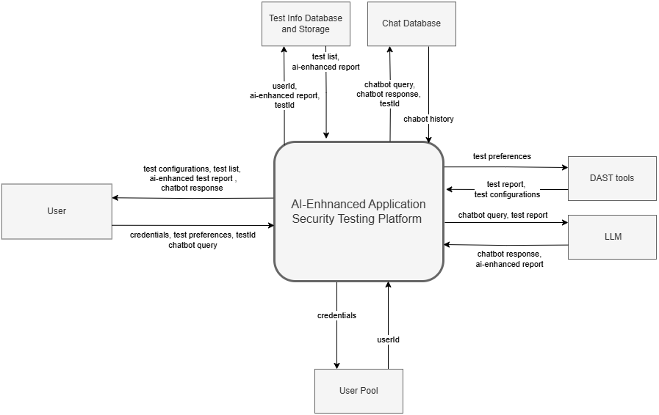Figure 3.2.1. Context Diagram of Security Testing Platform Design

#### Diagram Explanation: Dataflow of Platform:

The security testing platform provides the following use cases:

* Authentication
  + The user enters its credentials, the platform verifies them with a User Pool and retrieves the user Id if successful.
* Launching a report
  + To launch a report, the platform fetches the available Configurations from the DAST tools and sends them to the user. The user then fills in their preferences, and then the platform reaches the DAST tools to launch the test using the user preferences. After the report is sent to the platform, it sends it to the LLM so that it can enhance it, providing a summary. Finally, the platform shows the AI-enhanced report to the user upon request.
* Retrieving List of Launched Reports
  + The platform can use the user Id to access the history of tests launched. After showing them to the user, he/she can ask for the report of a certain test.
* AI-enhanced Test Report:
  + The user can request the AI-enhanced test report by sending the test Id of the desired report. Then, the platform retrieves it from the database and shows it to the user.
* Chatbot:
  + The user can make an inquiry to the chatbot regarding an ai-enhanced test report by sending its inquiry and the test Id. The platform will shortly prompt the LLM model to get its response. The it will store both messages in the Chat database, and retrieve the full chat history, and display it to the user.

### 3.2.2 High-Level System Diagram

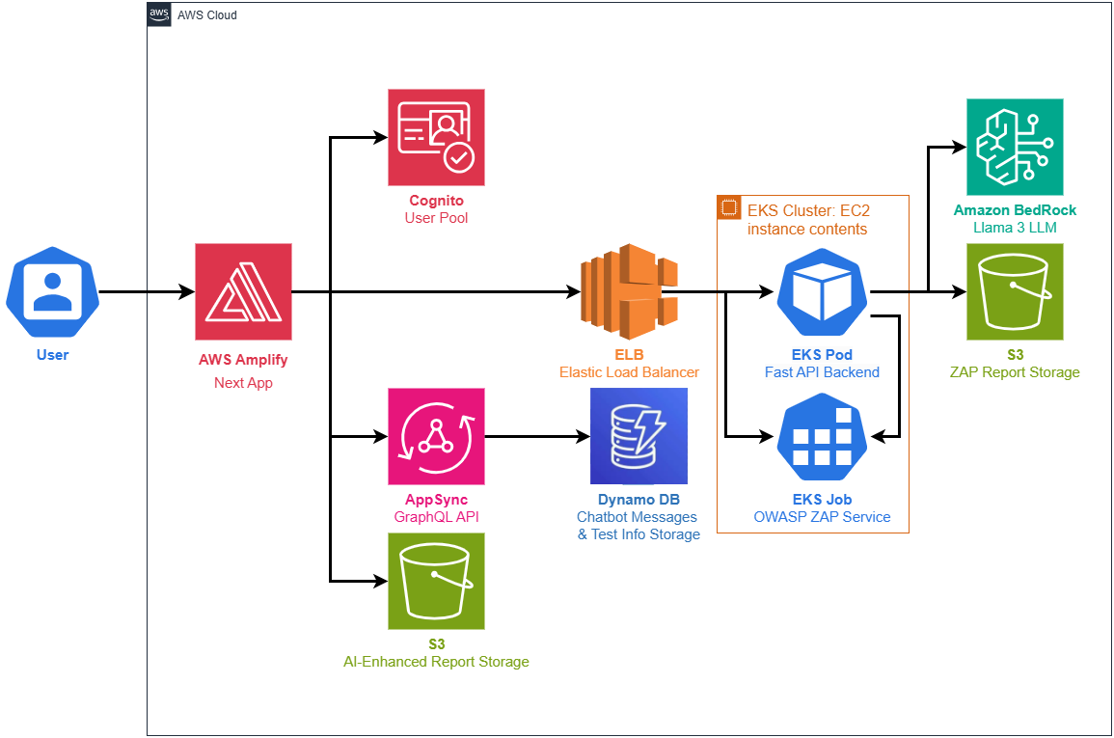

Figure 3.2.2: High-Level System Architecture

#### Diagram Explanation: Security Scan Workflow:

As seen in Figure 3.2.2, users interact with the web application hosted on AWS Amplify, which uses AWS Cognito for authentication. Once a user creates a new test, the server side of the Next.js Application contacts an Elastic Load Balancer (ELB) which redirects the request to a Kubernetes Pod hosted on an EC2 server (by the AWS EKS) which then triggers a Job to run an OWASP ZAP Base Scan, detecting vulnerabilities in the web application. The scan results are processed and stored in Amazon S3 as raw reports. These reports are then passed to AWS Bedrock, which analyzes the findings and generates clear report-suggested solutions. The final report is stored and displayed through the web interface. For the chatbot functionality, the client side of the Next.js API handler will forward the user prompt and report (as context) to the Fast API backend, which responds with the answer of the LLM. The system uses AWS EKS Cluster to manage containerized workflows and AWS Elastic Load Balancer to efficiently handle requests ensuring scalability, reliability, and a seamless user experience. The estimated monthly AWS fees are around $86 USD (see Appendix D for the cost breakdown).

### 3.2.3 High-Level Web Design

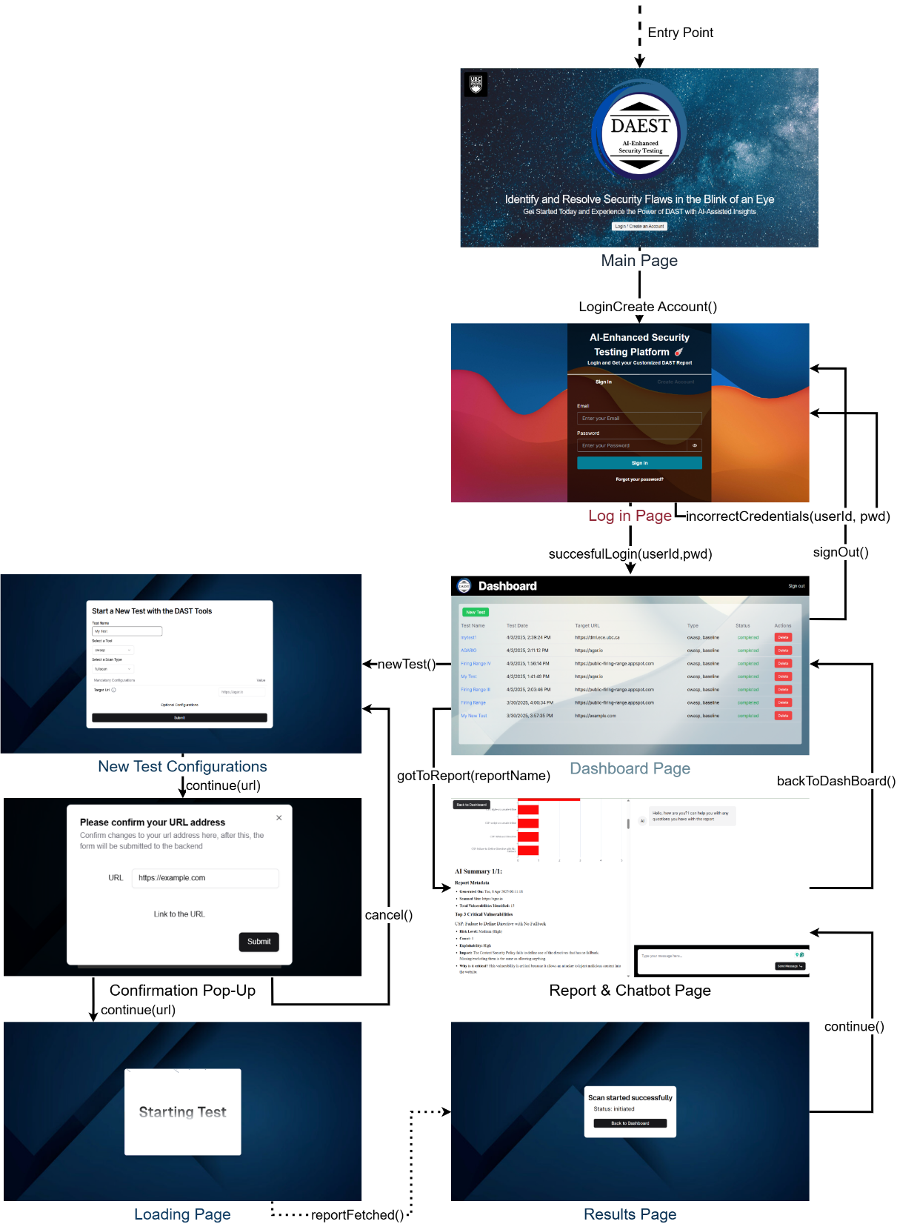

Figure 3.2.3: User Interface Navigation Diagram Some UI components of the web pages have been exaggerated for visualization purposes, for the exact proportions refer to Appendix B: Webpage UI. The blue link symbols denote web pages external to the platform. For usage instructions please visit Appendix C.

#### Diagram Explanation: User Workflow:

The user workflow of our platform depicted in figure 3.2.3 can be broken down into the following steps.

1. An unauthenticated user begins at the **Main Page**, as shown in *Figure 3.2.3*, where they are prompted to log in.
2. On the **Login Page**, the user must enter valid credentials (username and password) to proceed.
3. The authenticated user is directed to the **Dashboard Page** (*Figure 3.2.3*), which displays all previously launched tests. From this page, the user may:
   1. Click **"Launch Test"** to initiate a new scan (Step 4), or
   2. Click on the name of a completed test to view its results (Step 8).
   3. Click on **“Sign Out”** (go back to Step 1)
4. Selecting **"Launch Test"** navigates the user to the **New Test Configuration Page**, where they can input the test name, choose a DAST tool and scan mode, specify the target URL, and optionally modify advanced configuration settings.
5. A confirmation dialog appears, allowing the user to validate the target URL via a direct link.
6. The **Loading Page** then briefly appears as the test is initialized.
7. Once the test is successfully initiated, the **Results Page** confirms that initialization is complete. The user may return to the **Dashboard Page** to monitor test status (step 3).
8. When accessing a completed test, the user is directed to the **Report + Chatbot Page**, which presents the security scan results on the left panel and an interactive AI assistant on the right. The user can review the report and ask questions related to its findings. Once finished, they can return to the **Dashboard Page**.

## 3.3 Database Design

The platform architecture consists of two NoSQL components. **Amazon DynamoDB** is used to store both the chat history and the dashboard test list. Each record includes a reportId, which references the associated enhanced report stored in **Amazon S3**.

Report files in the S3 bucket follow a consistent path structure:

reports/<entity_id>/<reportId>.json

This configuration ensures reliable linking between metadata and report files, enabling efficient data retrieval and system scalability.

### 3.3.1 Tests

In Figure 3.3.1 we can see the class diagram of the Test Schema. All information except for the report id is used by the Dashboard to show the table of tests run. The reportId is necessary for the retrieval of the report used. Note that no userID is needed because the Cognito integration with AWS Amplify sets the entity_id of the user when fetching the report from the S3 bucket.

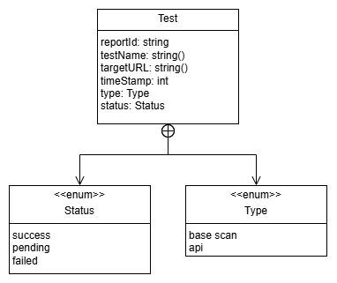

Figure 3.3.1: Class Diagram of the Test Schema

### 3.3.2 Chat Database Diagram

As seen in Figure 3.3.2 the Chat schema is just a composition of messages, where the sender can either be the user or the AI model. Since a chat is linked to as single report, and a test must include the report id, the Chat is also identified by the reportId. Each message only supports text input, and the date is calculated from a time stamp.

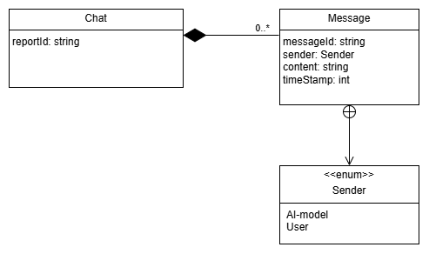

Figure 3.3.2: Class Diagram of the Chat Schema

# 4. Design Decisions and Justifications

This section outlines key design decisions made during the development of the AI-enhanced application Security Testing Platform. Each decision is linked to specific functional and non-functional requirements to ensure a well-structured, scalable, and efficient system.

### Table 4.1: Design Decisions and Justifications Table

The table below summarizes the critical design decisions made during the development of the platform, linking them to specific functional and non-functional requirements. Each decision is justified based on its contribution to achieving the project’s objectives.

|  |  |  |
| --- | --- | --- |
| **Component** | **Decision & Associated Requirements** | **Rationale** |
| **AI** | **Decision:** AWS Bedrock for AI-powered security report analysis and summarization  **FRs:** FR-3, FR-4  **N-FRs:** NFR-2, NFR-5, NFR-9, NFR-10, NFR-11, NFR-12 | AWS Bedrock offers seamless setup **(NFR-9)**, cost-effective deployment **(NFR-11)**, and efficient fine-tuning capabilities **(NFR-10)**.  Its fully managed infrastructure eliminates the need for extensive model hosting and maintenance **(NFR-9)** while providing comprehensive documentation **(NFR-5)**.  Additionally, it allows for easy model swapping and feature scalability **(NFR-12)**. |
| **Authentication & Access Control** | **Decision:** AWS Cognitofor User access.  **FRs:** FR-10  **N-FRs:** NFR-3, NFR-9, NFR-12, FR-14 | **Cognito Justification:**  AWS Cognito is a scalable user access service that improves the security of the platform. The platform administrator can easily import existing user pools or he/she can leave the default which aligns with the minimal configurations (**NFR-14)**. Cognito scales to millions of users **(NFR-3).** In addition, when managed with AWS Amplify, automatic identity checks can be achieved for database accesses (**FR-10)**, allowing for ease of feature expansion **(NFR-12)** and keeping the simplicity of the implementation **(NFR-9).** |
| **Backend** | **Decision:** Use Python FastAPI server for API handling  **FRs:** FR-1, FR-2, FR-3, FR-6, FR-7, FR-8.  **N-FRs:** NFR-6, NFR-8, NFR-9 | FastAPI was selected due to its high performance (async support), lightweight nature, and automatic OpenAPI generation, which simplifies API documentation and usability **(NFR-8)**. It allows rapid development and easy integration with OWASP ZAP and LLM services, aligning with our vulnerability scanning and LLM report summarization requirements **(FR-2, FR-3, FR-6)**.  Additionally, FastAPI’s asynchronous support ensures efficient handling of concurrent security scan requests, improving system performance **(NFR-6)**. Its built-in validation and dependency injection enhances maintainability and simplicity **(NFR-9)**. |
| **Cloud Infrastructure** | **Decision:** Utilize AWS EKS (Kubernetes) for workload orchestration  **FRs:** FR-1, FR-2, FR-3, FR-6, FR-7  **N-FRs:** NFR-1, NFR-3, NFR-7, NFR-9, NFR-11 | AWS EKS provides scalability (**NFR-12**), cost-efficiency (**NFR-11**), and ease of maintenance (**NFR-9**). It allows seamless auto-scaling, optimized resource allocation, and simplified deployment management for the backend, LLM, and security scanning workloads(**NFR-9**). The choice aligns with our requirement for containerization and modularity **(NFR-1)**, ensuring we can replace backend and LLM images easily.  Kubernetes also reduces operational complexity and minimizes infrastructure costs **(NFR-11)** by dynamically allocating resources. |
| **Infrastructure as code (Iac)** | **Decision:** Use AWS CDK (CloudFormation) for infrastructure provisioning.  **N-FRs:**NFR-1, NFR-5, NFR-7, NFR-9 | AWS CDK provides repeatable, version-controlled, and automated deployments, ensuring consistency across environments. It simplifies resource management by defining EKS clusters, IAM roles, S3 storage, and networking as code, reducing manual configuration errors.  This approach aligns with modularity **(NFR-1)**, improves documentation and maintainability **(NFR-5)**, and enhances reliability and security **(NFR-7, NFR-9)**. |
| **Containerization** | **Decision:** Docker for containerization  **N-FRs:**NFR-1,NFR-5,NFR-13 | Docker is natively supported across various AWS architectures. making it easier to update, manage, and scale.  Additionally, Docker is **open-source**, aligning with the project's commitment to **open-source-first architecture** **(NFR-13)**. |
| **Data Storage** | **Decision:** S3 for raw documents and system configuration  **Decision:** AWS Amplify managed S3 bucket and DynamoDB for enhanced report storage and Chat Messages  **N-FRs:**NFR-3, NFR-7, NFR-11, NFR-12, NFR-14 | **S3 bucket mounted on EKS to store reports**  It provides shared storage access across distributed Kubernetes pods, unlike node-bound EBS volumes. It offers cost-effective pay-per-use pricing **(NFR-11)** for intermittent access patterns, ensures 99.99% durability through built-in replication **(NFR-7)**, and enables seamless integration with AWS services such as EventBridge and Bedrock for extended functionality **(NFR-7)**.  **S3 Bucket and DynamoDB Managed by AWS Amplify Backend**  The main advantage of having the AI-enhanced reports and Chats on an S3 bucket and DynamoDB, respectively managed by AWS amplify is that it provides direct integration with IAM authentication. This allows for seamless feature scalability **(NFR-12)** as the application administrator will have the option to either let the service be an open or closed model and the user-managed database configurations will adapt accordingly to the preferred authentication types. In addition, it provides automatic integration to serverless querying configured by Lambdas and Appsync. This makes user scalability **(NFR-3)** possible while having minimal computing tradeoffs. Lastly, these services do not require any further configurations for deployment. This allows for quick and flawless deployment **(NFR-14).** |
| **User Interface (UI)** | **Decision:** React.  **FRs:** FR-1  **N-FRs:** NFR-8, NFR-13 | React is a popular user interface framework that is flexible and supports the modularization of components **(FR-1)**. In addition, a wide variety of UI component libraries are based on React. For example, ShadCN is a widely used UI component library which offers a wide amount of styled-components. The current implementation uses the ShadCN component library and these components are only compatible with React. Therefore, React components improve the usability of the platform as it becomes easier to create a responsive and intuitive UI **(NFR-8).** Lastly, React is the only UI framework that Nextjs, the chosen frontend framework, supports. |
| **Vulnerability Scanner** | **Decision:** Adoption of OWASP ZAP for automated black-box security testing.  **FRs:**FR-2, FR-6, FR-7, FR-9  **N-FRs:**NFR-1, NFR-2, NFR-3, NFR-5, NFR-6, NFR-7, NFR-13 | OWASP ZAP is a trusted, open-source (**NFR-13**) industry standard for security testing, providing both basic and advanced scanning capabilities **(FR-9)**. It offers real-time updates **(FR-7)**, configurable scan options **(FR-6)**, extensive documentation **(NFR-5)**, and strong community support. For more details, refer to the following links:   * [Recommended by AWS](https://aws.amazon.com/blogs/devops/building-end-to-end-aws-devsecops-ci-cd-pipeline-with-open-source-sca-sast-and-dast-tools/) * [Zap community](https://www.zaproxy.org/community/) |

### Table 4.2: Alternative Choices Considered Table

This table evaluates alternative technologies for key system components, selecting the most scalable, secure, and cost-efficient options based on project needs.

|  |  |  |  |
| --- | --- | --- | --- |
| **Component** | **Evaluated Options** | **Requirements & Comparison** | **Description** |
| **AI Service** | **Chosen Option:** AWS Bedrock  **Alternative:**  SageMaker | **SageMaker:**  FR-3, FR-4, NFR-10  **AWS Bedrock:**  FR-3, FR-4, NFR-9, NFR-10 | AWS Bedrock was chosen for its ease of integration, reduced operational overhead, and lower cost. - SageMaker was more flexible but required higher infrastructure and maintenance costs.  If the design does not achieve the required accuracy (as defined in **NFR-10**) with Bedrock, this decision may be reviewed to explore alternative solutions. |
| **LLM (Large Language Model)** | **Chosen Option:** Lamma Meta 3  **Alternative:**  Titan | **Llama 3 (Meta):**  FR-3, FR-4, FR-5, NFR-2, NFR-5, CST-5, CST-6, CST-7  **Amazon Titan:**  FR-3, FR-4, NFR-2, NFR-5, NFR-9, NFR-11, CST-5, CST-6  (Does not satisfy CST-7) | This decision was made based on client recommendations and the model’s cybersecurity knowledge.  **Amazon Titan (AWS Bedrock)** is better suited for long report summarization and structured Q&A. It supports full fine-tuning customization, is optimized for AWS with seamless S3, and DynamoDB **(NFR-9)**, and offers lower cost **(NFR-11)** & faster response for structured security workflows. However, it lacks pre-trained cybersecurity knowledge **(CST-7)**.  **Llama 3 (AWS Bedrock)** is better for free-form cybersecurity Q&A and reasoning-based risk assessments **(FR-5)**. It does not support fine-tuning on Bedrock and relies on RAG for updates. While it is pre-trained on general security knowledge, making it stronger for unstructured queries, it comes with higher costs and slower response times for long, complex queries. |
| **Authentication & Access Control** | **Chosen Option:** AWS Cognito  **Alternative:** JWT based authentication, Firebase Authentication | **FRs:** FR-10  **N-FRs:** NFR-3, NFR-9, NFR-12, FR-14 | **JWT Based Authentication:**  A custom implementation with user management logic where we handle JWT tokens can result in buggy and insecure. This would not be as cost-efficient as the serverless logic Cognito offers and has to be handled manually. In addition, this would require additional testing for a secondary feature. Furthermore, it would not allow ease of feature expansion as it will not be able to import user pools directly from the platform administrator. Therefore, this implementation would show limited support for NFR-12 and NFR-14.  **Firebase Authentication:**  Firebase offers similar automation in authentication, it is simple and supports various authentication methods such as email and social media federated authentication. However, it fails to integrate with other AWS Amplify libraries so custom implementations have to handle the authentication, limiting feature scalability **(NFR-12)**. In addition, user pools cannot be imported to the platform so every single user will have to create an account or use some non-desired method of authentication failing to offer a closed system model. |
| **Backend** | **Chosen Option:** Python & FastAPI  **Alternative:** Flask & Django | Flask:  FR-1, FR-2, FR-8, NFR-6, NFR-8, NFR-9  Django:  FR-1, FR-2, FR-8, NFR-6, NFR-8  FastAPI:  FR-1, FR-2, FR-8, NFR-6, NFR-8, NFR-9 | Flask is lightweight but lacks built-in async support, making it less efficient for handling concurrent requests. Django is powerful but introduces unnecessary overhead for an API-first application. FastAPI provides superior performance with asynchronous request handling, built-in validation, and automatic OpenAPI documentation, making it the best choice for integrating with security scanning and AI-based reporting. |
| **Cloud Infrastructure** | **Chosen Option:** Kubernetes  **Alternative:**  EC2 instances | **EC2:**  FR-1, FR-3, FR-6, FR-7, NFR-9  **Kubernetes:**  FR-1, FR-3, FR-6, FR-7, NFR-1, NFR-3 | - Kubernetes provides better scalability, maintainability, and cost efficiency compared to running services on standalone EC2 instances.  - It allows dynamic scaling of workloads, automated deployments, and efficient resource utilization.  - Given our requirement to replace LLM and backend images easily, Kubernetes enables rolling updates without downtime. |
| **Infrastructure as Code (IaC)** | **Chosen Option:** AWS CDK  **Alternative:**  Terraform | — | Client’s specific demand to use AWS CDK as UBC CIC is AWS subsidiary |
| **Containerization** | **Chosen Option:**  Docker  **Alternative:**  None | NFR-1, NFR-3,NFR-9,NFR-12, | Other alternatives were not evaluated since Docker is natively supported across various AWS architectures. making it easier to update, manage, and scale. |
| **Data Storage** | **Chosen Option:** S3, DynamoDB  **Alternative:**  **S3 bucket mounted on EKS to store reports**  EBS (Elastic Block Store), EFS (Elastic File System), RDS  **Amplify S3 and DynamoDB** | EBS:  NFR-4, NFR-6, NFR-7  EFS:  NFR-4, NFR-6, NFR-7  RDS:  NFR-4, NFR-6, NFR-7  S3:  NFR-4, NFR-6, NFR-7, NFR-11 | **S3 bucket mounted on EKS to store reports**  EBS provides high-speed block storage but is tied to a specific EC2 instance and requires manual scaling. EFS supports multiple pods but incurs higher costs for frequent small file storage. RDS is not optimized for storing large, unstructured security reports. S3 was chosen because it is highly scalable, cost-effective, and integrates seamlessly with AWS services. It provides secure, durable, and highly available object storage for storing ZAP scan reports while ensuring encryption and controlled access policies. |
| **Front-End Language** | **Chosen Option:**  TypeScript &  Tailwind CSS  **Alternative:** Javascript & HTML with CSS | FR-1, NFR-2, NFR-4, NFR-5, NFR-7, NFR-9 | We choose Typescript over JavaScript for the web app as TypeScript prevents runtime errors by enforcing type checking at compile time. This is critical for security-focused applications where small errors (e.g., undefined values, incorrect API responses) can lead to serious vulnerabilities.  We choose Tailwind CSS instead of HTML with CSS as Tailwind’s classes make styling components much faster than writing separate CSS files. Moreover, it also Improves page load times, which is important for our project since we want our product to be reliable and fast. |
| **User Interface (UI)** | **Chosen Option:** React  **Alternatives:**  Vue, Angular | FR-1, NFR-8, NFR-9, NFR-13 | React follows a component-based architecture, allowing us to efficiently reuse UI elements across different parts of the application. This modular approach simplifies development and maintenance. Additionally, React has a vast ecosystem of libraries and pre-built UI templates, which accelerates development by reducing the need to design the UI from scratch. Compared to Vue and Angular, React offers broader community support and a richer selection of third-party templates, making it the preferred choice for our project. |
| **Vulnerability Scanner** | **Chosen Option:** OWASP ZAP  **Alternative:**  Burp Suite | OWASP ZAP:  FR-2, NFR-9, NFR-11  Burp Suite: FR-2, NFR-9 | OWASP ZAP was selected as the primary DAST tool due to its strong industry reputation, active community support, and proven reliability in detecting vulnerabilities. While tools like Burp Suite provide **advanced manual testing features**, ZAP is **open-source and widely used for automated black-box security testing**, making it **cost-effective and easy to integrate into automated workflows (NFR-11)**. Additionally, **the client explicitly demanded OWASP ZAP**, further reinforcing the decision. |

# 

# 5. Challenges and Risk

This section outlines key technical challenges and risks encountered during development, along with their severity and mitigation strategies. Table 5.1 categorizes challenges based on their impact. Each entry details the issue, its potential consequences, and the measures implemented to address it. This structured approach ensures proactive risk management and continuous system optimization.

This section also presents key future considerations. Table 5.2 outlines strategic improvements aimed at maintaining system efficiency, and adapting to technological advancements. Each category highlights ongoing and future optimizations.

### 5.1 Technical Challenges

|  |  |  |  |
| --- | --- | --- | --- |
| **Challenge/Risk** | **Severity** | **Description** | **Mitigation** |
| **Scalability Under Load** | **High** | Managing concurrent operations efficiently, including long-running OWASP ZAP scans, LLM processing requiring GPU acceleration, and S3 storage operations for large security scan reports. | Leveraged Kubernetes (EKS) for horizontal scaling, configured EKS auto-scaling, implemented timeout handling (1800s), and conducted load testing. |
| **LLM Accuracy** | **Medium** | Due to the probabilistic nature of LLMs, results cannot be guaranteed to be 100% accurate and may require user validation. | Prioritize LLMs with high cybersecurity knowledge and advanced fine-tuning capabilities to improve accuracy in cybersecurity report summaries and interactive assistance. |
| **Reliability of DAST Tool** | **Medium** | Ensuring OWASP ZAP performs accurate scanning and identifies vulnerabilities reliably. | Verified ZAP functionality by analyzing its generated reports, which include a list of all the tests executed during the scan.  Validated ZAP’s efficacy by running it against a test web application containing known vulnerabilities, confirming that ZAP accurately identified them.  Ensured transparency by integrating ZAP’s logs and reports into the platform for user review and auditability. |
| **Data Security and Privacy** | **High** | Safeguarding sensitive data during testing and report generation. | Enforced proper IAM roles and Kubernetes Role-Based Access Control (RBAC). Configured secure S3 storage with bucket-level and object-level permissions. Deployed workloads in isolated VPCs with secure networking policies.Implemented Kubernetes security policies for containerized components. |
| **Resource Management** | **Medium** | Inefficient resource allocation leads to increased costs. | Configured auto-scaling for EKS nodes, and defined resource limits for Kubernetes deployments. |
| **System Reliability** | **High** | Downtime or inconsistent performance due to system errors. | Multi-AZ deployment, robust error handling, monitoring tools, and regular backups. |
| **Integration Points** | **Medium** | Failures in interconnected services such as ZAP, LLM, and storage. | Built-in error-handling mechanisms, circuit breakers to mitigate cascading failures, and comprehensive logging for debugging. |
| **Scalability and Optimization** | **Medium** | Planning for evolving workloads and maintaining performance efficiency. | Regular performance testing, capacity planning, and Kubernetes fine-tuning. |
| **AI/LLM Evolution** | **Low** | Staying updated with advancements in open-source LLMs and optimizing model configurations. | Evaluating newer models, conducting A/B testing, and refining prompt engineering. |
| **Security Enhancements** | **High** | Maintaining a secure infrastructure and minimizing vulnerabilities. | Periodic security audits, dependency updates, and additional security layers for sensitive data. |
| **Migration to Serverless Architecture** | **Medium** | The client has expressed a preference for a serverless architecture. While the current implementation uses EKS-based Kubernetes orchestration, an evaluation is required to determine if migrating to a serverless solution (AWS Lambda or Step Function) would offer better cost-efficiency and performance scalability. | Develop a Proof of Concept (PoC) deploying a serverless-based workload to compare against the existing EKS setup   * Deploy ZAP scan jobs on AWS Fargate instead of EKS to test execution time and cost efficiency * Simulate 50 concurrent users executing baseline scan (includes LLM interference) in both EKS and serverless environment. Then evaluate cost and resource consumption * Evaluate operational complexity |

### 

### Table 5.2: Future Considerations

|  |  |
| --- | --- |
| **Category** | **Considerations** |
| **Scalability and Optimization** | Regular performance testing and optimization based on usage metrics.  Capacity planning to accommodate evolving workloads.  Fine-tuning Kubernetes configurations for scaling and cost efficiency. |
| **AI/LLM Evolution** | Stay updated with advancements in open-source LLMs.  Evaluate and integrate newer, more efficient models as they become available.  Conduct A/B testing to optimize prompt design and model configuration. |
| **Security Enhancements** | Periodic security audits of cloud infrastructure.  Regular updates for dependencies and Kubernetes versions.  Adding further layers of security for sensitive data and services. |

# 

# 6. Appendices

## Appendix A: Platform Deployment

### 6.1 Frontend + Amplify Backend Deployment

The front end is to be deployed on AWS Amplify. Since Amplify Gen 2 is designed around GitOps-based workflow, a Git repository is needed for deployment. Thus, you need to create a GitHub Repo, for this example, we will assume the URL of your repo is https://github.com/<myUname>/<myRepo>.git. Then open your terminal and run the following commands to clone our repository into yours (MacOS terminal and Windows Powershell):

|  |
| --- |
| git clone https://github.com/UBC-CIC/AI-Enahanced-Secutity-Testing-ECE-Capstone.git myRepo  cd myRepo   git remote add origin https://github.com/<myUname>/<myRepo>.git  git add .  git commit -m"Cloned AI-Enhanced-Security-Testing-ECE-Capstone repo"  git push -u origin main |

Now that you have the application in your GitHub repository go to the AWS console at <https://aws.amazon.com/>. Then search for the AWS Amplify Service. Then select Create New App. For the first step select Github as your Git provider and click ‘next’ as shown in Figure 6.1.1.1. After that, allow AWS to access your GitHub repositories, as seen in Figure 6.1.1.2 choose the repository where you have your cloned application, choose main as your branch, select ‘My app is a monorepo’ and enter src/frontend as the root directory and click on next. Then go to environment variables, add variable named 'NEXT_PUBLIC_BACKEND_URL' with the url of the backend Elastic Load Balancer (ELB) as the value, as seen in Figure 6.1.1.3. Lastly, click ‘next’ for step 3 and ‘save and Deploy for step 4’. Now you have successfully created the AWS Amplify application, it will take around 5 minutes to build and deploy.

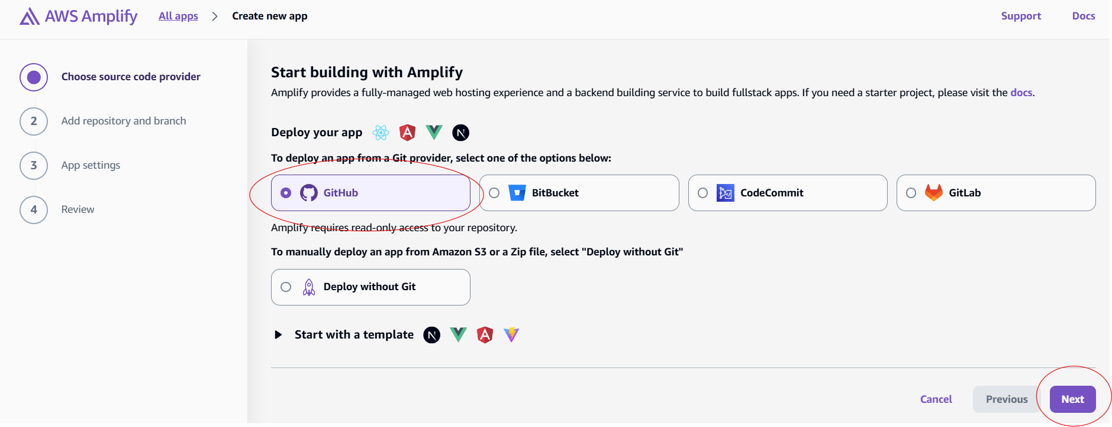

Figure 6.1.1: Creating Amplify Application Step 1

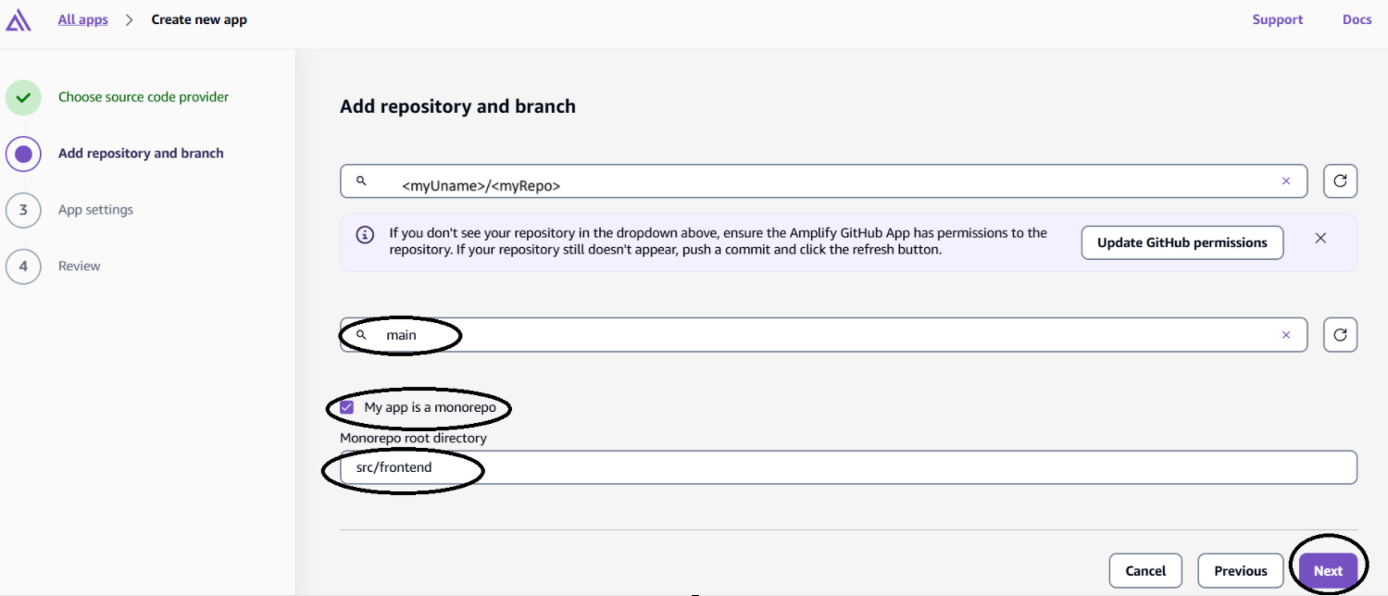

Figure 6.1.2: Creating Amplify Application Step 2

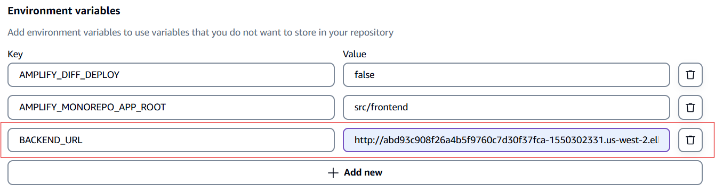Figure 6.1.3: Creating Amplify Application Step 3

### 6.2 Backend Deployment - AWS Infrastructure Deployment

#### Prerequisites

|  |
| --- |
| # Install AWS CDK npm install -g aws-cdk  # Install Python dependencies pip install -r requirements.txt  # Configure AWS credentials aws configure |

#### Deployment Steps

To begin deployment,

1. first bootstrap the AWS CDK environment using cdk bootstrap (required only for the initial setup).
2. Before deploying, review the planned infrastructure changes by running cdk diff.

To deploy the infrastructure:

1. Deploy all stacks using cdk deploy. This is recommended for the first deployment to ensure all dependencies and resources are provisioned correctly. Deployment logic is defined within the codebase.
2. Alternatively, to deploy a specific stack, use cdk deploy <stack-name>.
3. Optionally, you may retrieve deployment outputs after the process completes for integration or verification purposes.

Cleanup should only be performed if you are fully aware of the consequences, as it will remove all provisioned resources. To destroy all stacks, use the command cdk destroy --all.

#### Best Practices

* Always review the output of cdk diff before deploying changes to ensure infrastructure modifications are intentional.
* Maintain all infrastructure code under version control to track updates and enable rollback if needed.
* Monitor AWS CloudWatch logs during deployment for error detection and validation.
* Design infrastructure stacks to be modular and loosely coupled to enhance maintainability and scalability.

#### Backend Server Deployment

* Prerequisites, Ensure the following tools are installed:
  + AWS CLI (can be installed on macOS using Homebrew: brew install awscli)
  + kubectl (install via Homebrew: brew install kubectl)
  + Helm (install via Homebrew: brew install helm)
* AWS Authentication:
  + Authenticate using AWS Single Sign-On (SSO) by running aws configure sso. Use the following values during configuration:
  + SSO start URL: [https://ubc-cicsso.awsapps.com/start/#](https://ubc-cicsso.awsapps.com/start/)
  + AWS Region: ca-central-1

#### Login using AWS SSO.

1. Once authenticated, your terminal session will be authorized to interact with AWS resources.
2. Navigate to the src/backend directory to build and deploy the Docker image.
3. Authenticate Docker with ECR using the following command: aws ecr get-login-password --region us-west-2 | docker login --username AWS --password-stdin 619071345478.dkr.ecr.us-west-2.amazonaws.com
4. Build the Docker image using: docker buildx build --platform linux/amd64 -t 619071345478.dkr.ecr.us-west-2.amazonaws.com/aest/backend:latest .
5. Push the image to Amazon ECR: docker push 619071345478.dkr.ecr.us-west-2.amazonaws.com/aest/backend:latest

To update the backend server on the EKS cluster, ensure the following steps are completed:

1. Update your Kubernetes configuration to point to the appropriate EKS cluster: aws eks update-kubeconfig --name AestEks80BF057B-2506a807db2c4f2d92182a45a5548bef --region us-west-2
2. Verify you are using the correct EKS context: kubectl config get-contexts
3. Navigate to the Helm directory: AI-Enahanced-Secutity-Testing-ECE-Capstone/helm
4. Upgrade the Helm release for the backend: helm upgrade backend-release ./helm/backend
5. Note that the Helm chart is configured to always fetch the latest Docker image from ECR.

To verify the new backend deployment,

1. you can retrieve the external IP address of the backend service using: kubectl get svc backend -o jsonpath='{.status.loadBalancer.ingress[0].hostname}'
2. Once retrieved, you can test the deployment by sending a curl request to the backend endpoint, for example: curl -X POST "http://<external-ip>/zap/basescan?target_url=https://google.com"
3. Note: You may use tools such as k9s instead of kubectl to manage and interact with your Kubernetes resources.

## Appendix B: Web Page UI

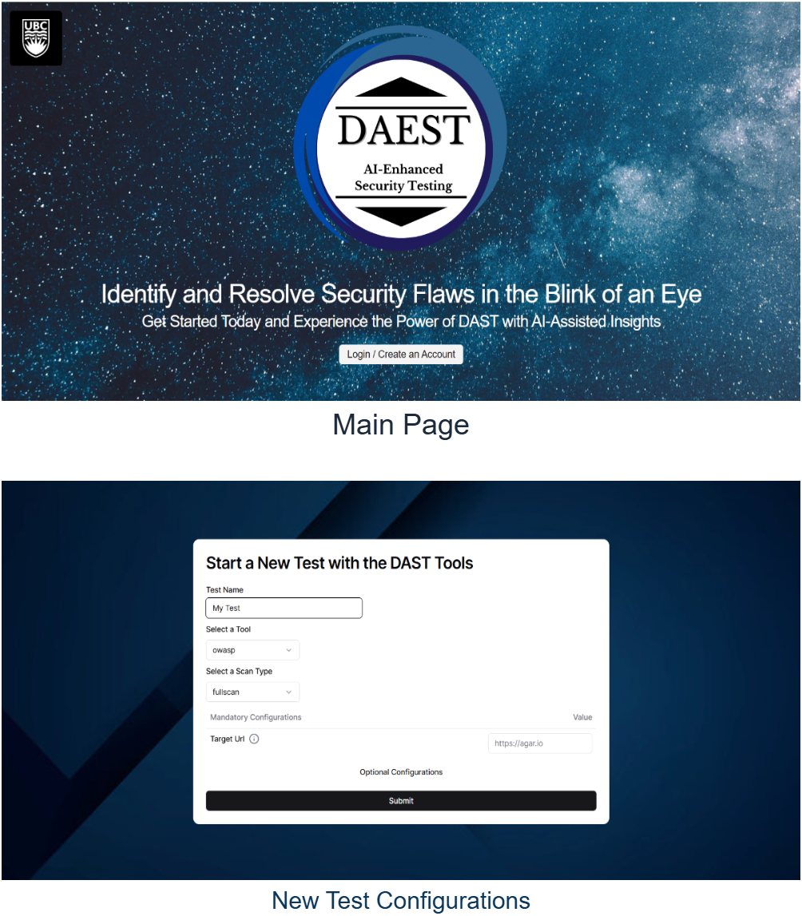

Figure 6.2.1: Main Page UI



Figure 6.2.2 New Test Configurations Page UI

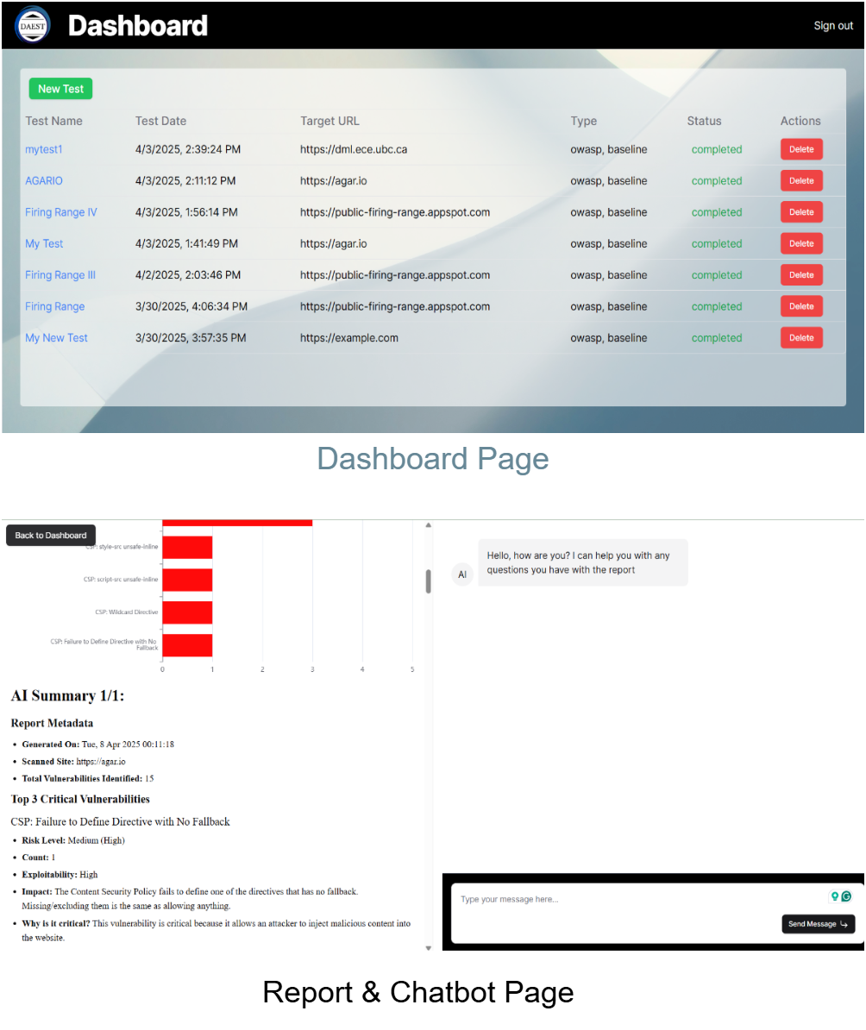

Figure 6.2.3 Dashboard Page UI



Figure 6.2.4: Chatbot Page UI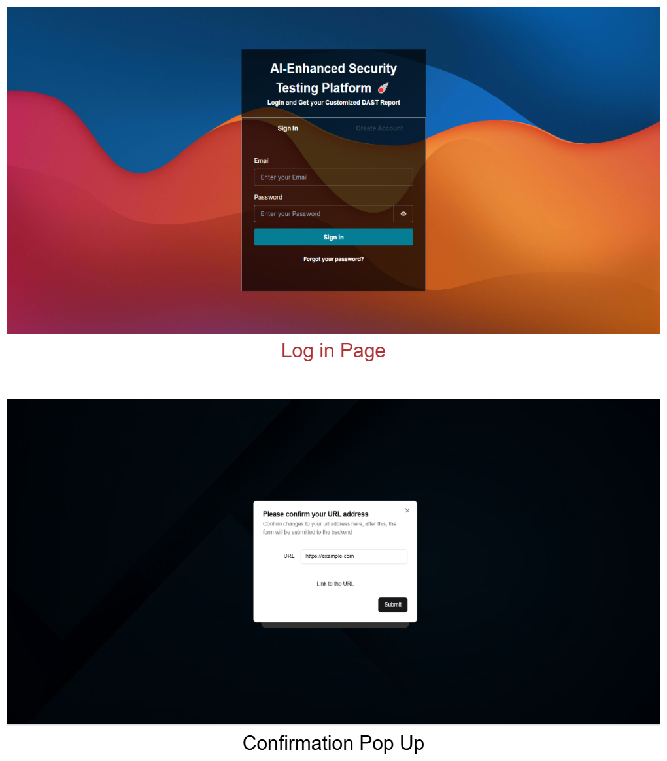

Figure 6.2.5: Login Page UI



Figure 6.2.6: Confirmation Po-up UI

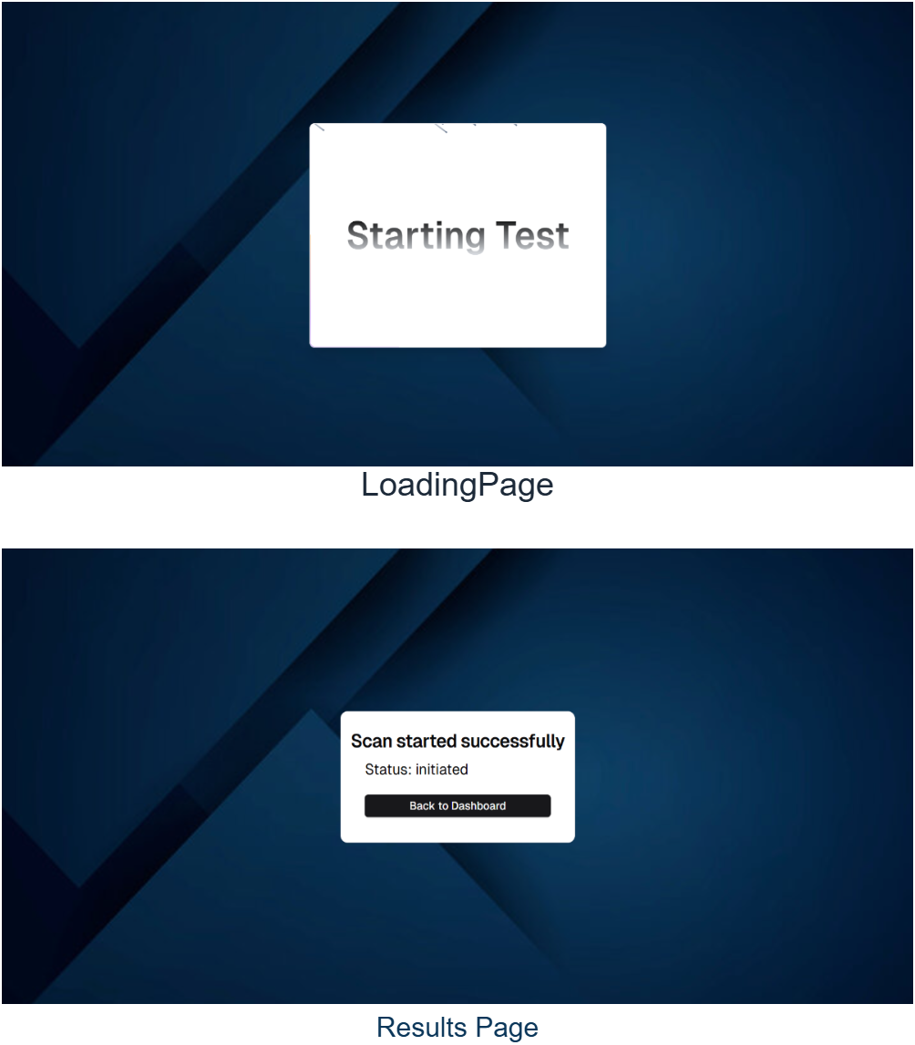

Figure 6.2.7: Loading Page UI



Figure 6.2.8: Results Page UI

## Appendix C: User Guide

### Launching a Security Test

**Prerequisites**  
Ensure you have the URL of the application or platform you wish to test.

**Steps to Launch a Test**

1. Navigate to the dashboard and click on **"New Test"**.
2. Configure your test by completing the following fields:  
   a. Enter a name for the test.  
   b. Select a security tool from the available options.  
   c. Choose the desired scan mode.  
   d. Provide the target URL for the application you want to test.  
   e. (Optional) Explore the "Optional Configurations" section to review or adjust any additional settings available for the selected tool and mode.
3. Click **"Submit"** to proceed.
4. To verify the URL, click **"Link to URL"** to preview the target site. Once confirmed, return to the test form and click **"Submit"** again to initiate the test.
5. The test should initialize within a few seconds. Once it starts, click **"Back to Dashboard"**.
6. The newly launched test will appear on the dashboard with a live status. Note that execution may take more than two minutes to complete, depending on the test configuration.

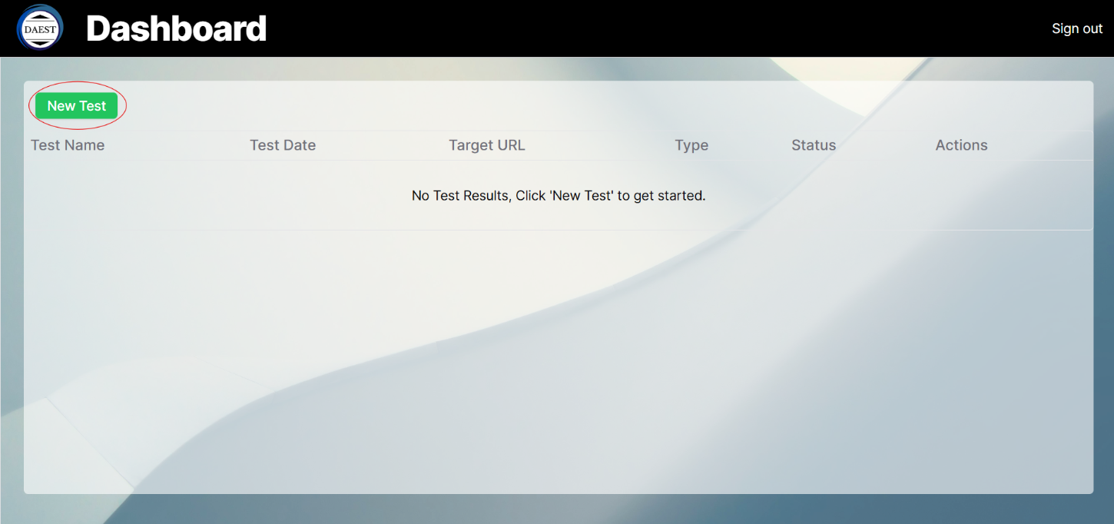

Figure 6.3.1. Launching a Security Test, Step 1

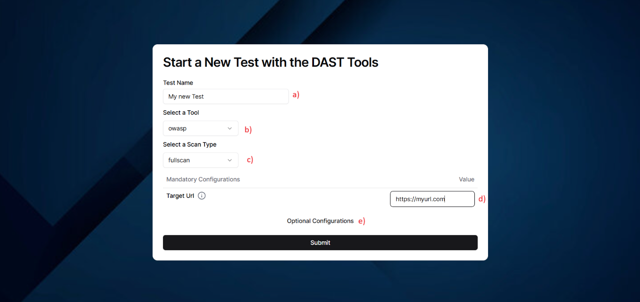

Figure 6.3.2. Launching a Security Test, Step 2

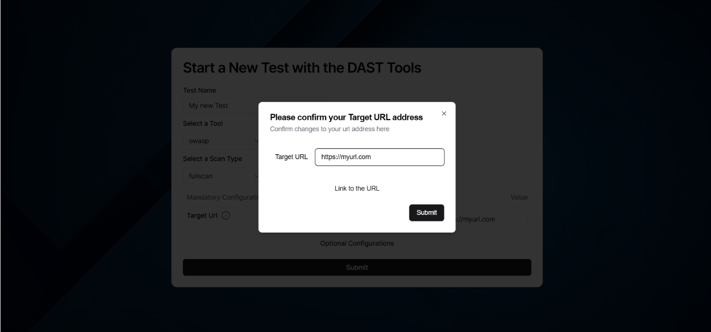

Figure 6.3.3. Launching a Security Test, Step 3

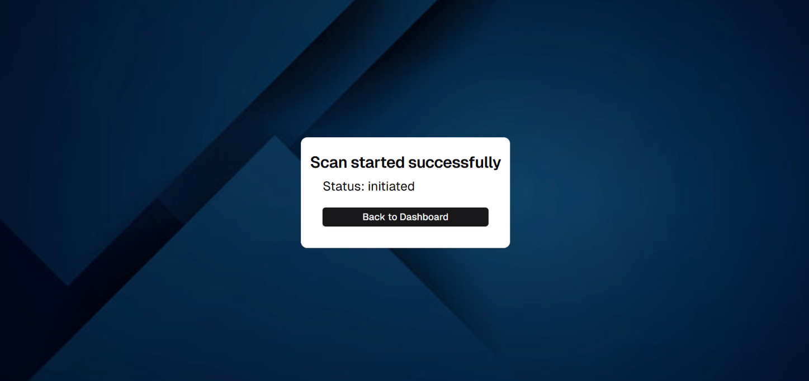

Figure 6.3.4. Launching a Security Test, Step 4

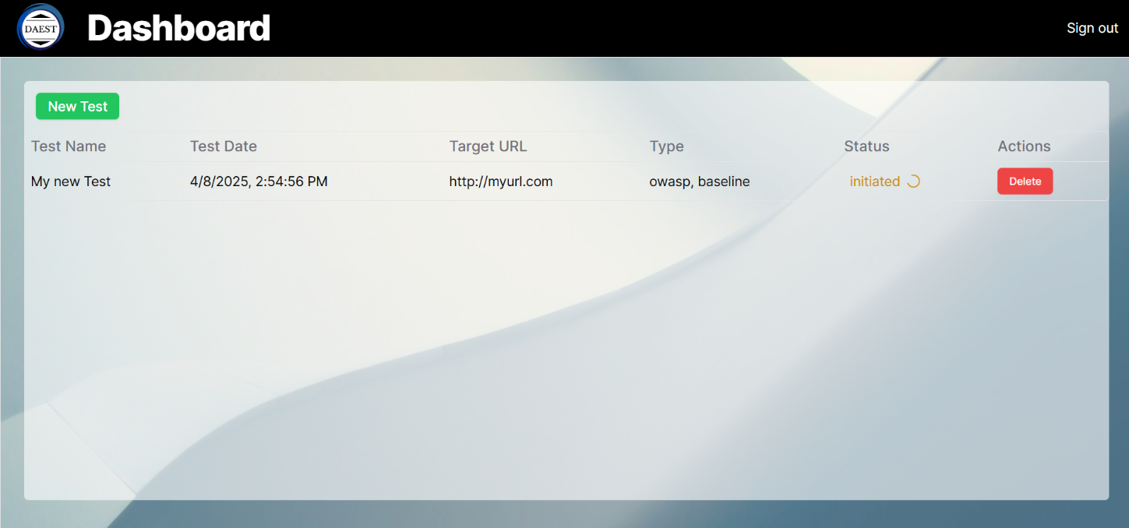

Figure 6.3.5. Launching a Security Test, Step 5

### Viewing a Completed Security Test Report

**Prerequisites**  
At least one security test must have been launched and completed.

**Steps to View the Report**

1. Monitor the test status on the dashboard and wait until it is marked as **Completed**.
2. Click on the test name, which will be displayed as a blue hyperlink.
3. You will be redirected to the detailed report page.

**Report Page Overview**

* Use the left-hand panel to navigate through different sections of the report, which includes:
  + A pie chart showing **Vulnerability Severity**
  + A histogram categorizing vulnerabilities by type
  + An **AI-generated summary** of the findings
  + A **tabulated report** generated by the selected security testing tool

**Additional Assistance**  
If you have questions or need clarification, you can interact with the AI assistant via the chatbot located on the right side of the page.

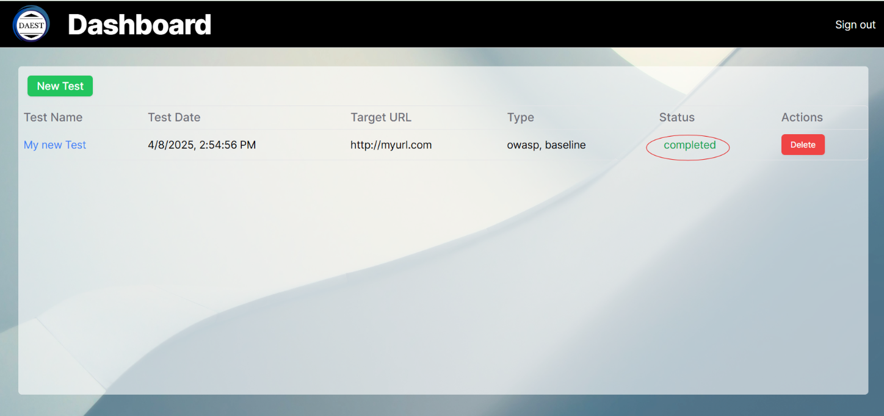

Figure 6.3.6. Accessing Test Results, Step 1

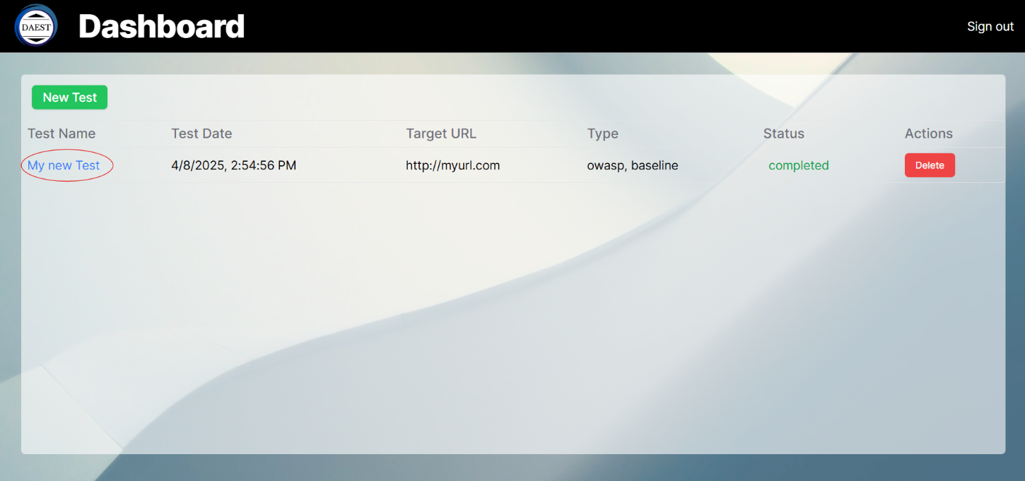

Figure 6.3.7. Accessing Test Results, Step 2

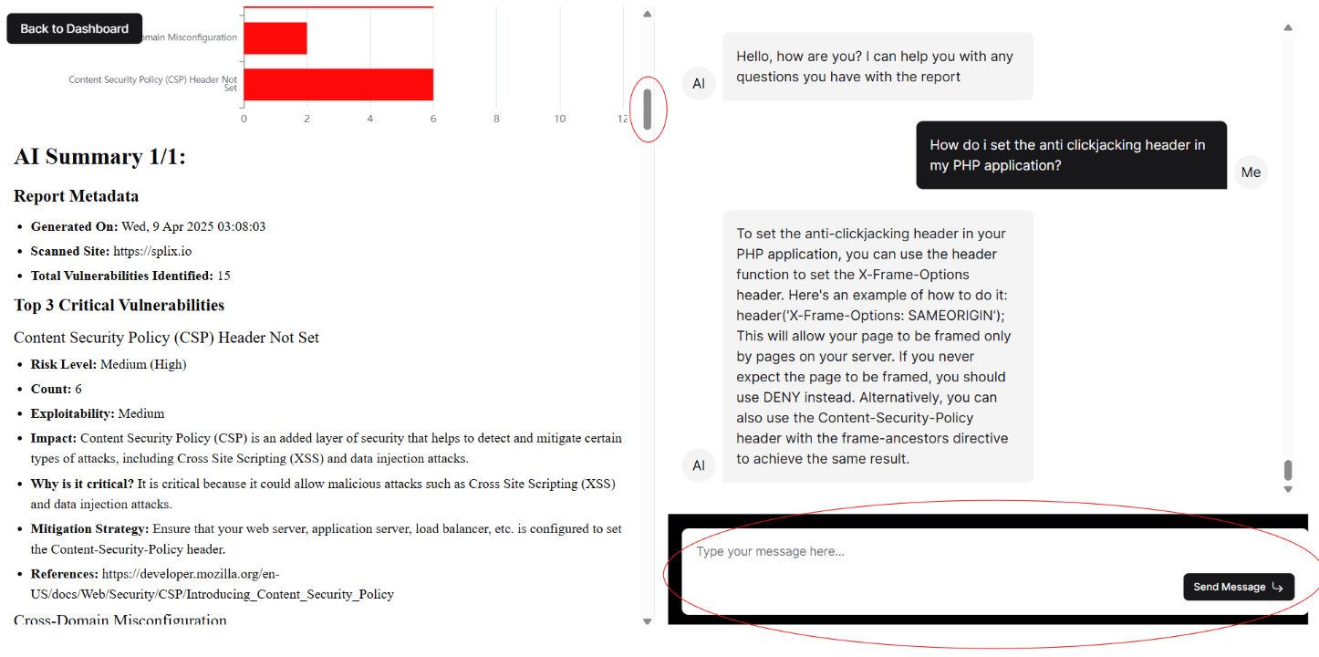

Figure 6.3.8. Accessing Test Results, Step 3

## Appendix D: Estimated Monthly Cost

This is an estimate for a team of 20 members having each member create 100 reports making on average 4 queries per chatbot. The cost is in US dollars.

